A PROJECT REPORT

ON

PRODUCTION OF FORMALDEHYDE FROM METHANOL (SENSITIVITY ANALYSIS)

For the partial fulfillment of the requirement for the degree of M.Tech (CAPE) in Chemical Engineering



Faculty TA Supervisor

**Mr. Tamal Banerjee Mr. Sanbed Das**

**Professor Mr. Sanjeev Patel**

Chemical Engineering Department

IIT Guwahati Submitted by

**Sudhakar Verma**

M.Tech(CAPE)

Roll No-234107206

* Desired to produce about 120,000 tons/year of Formaldehyde (99.1%) and by- product pure nitrogen which originally onsets from the inlet air
* Deside on the property method and come up with the proper design to end up with atleast 99.1 wt.% pure formaldehyde and 99.1 wt.% pure nitrogen at the indicated annual production rate

# Component Specification :-

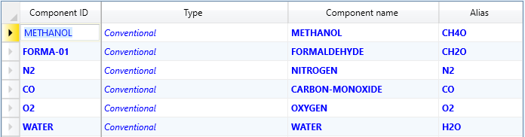

Property Method Specification :-

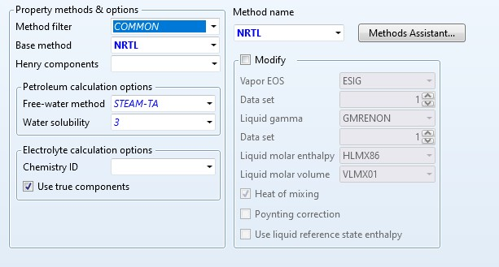

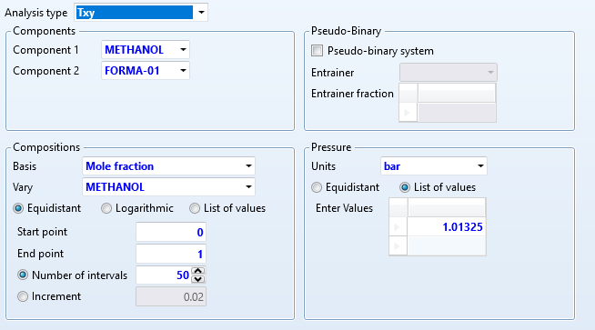

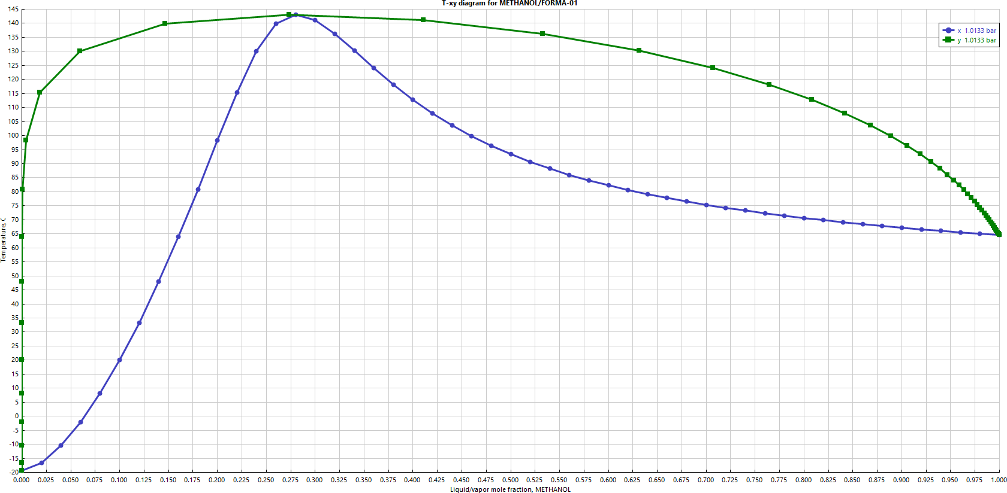

Temperature **vs** liquid/vapour mole fraction of METHANOL

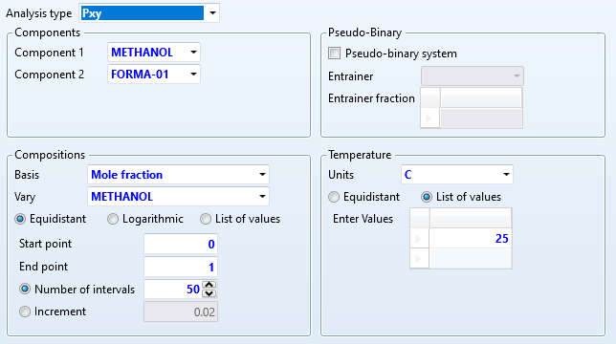

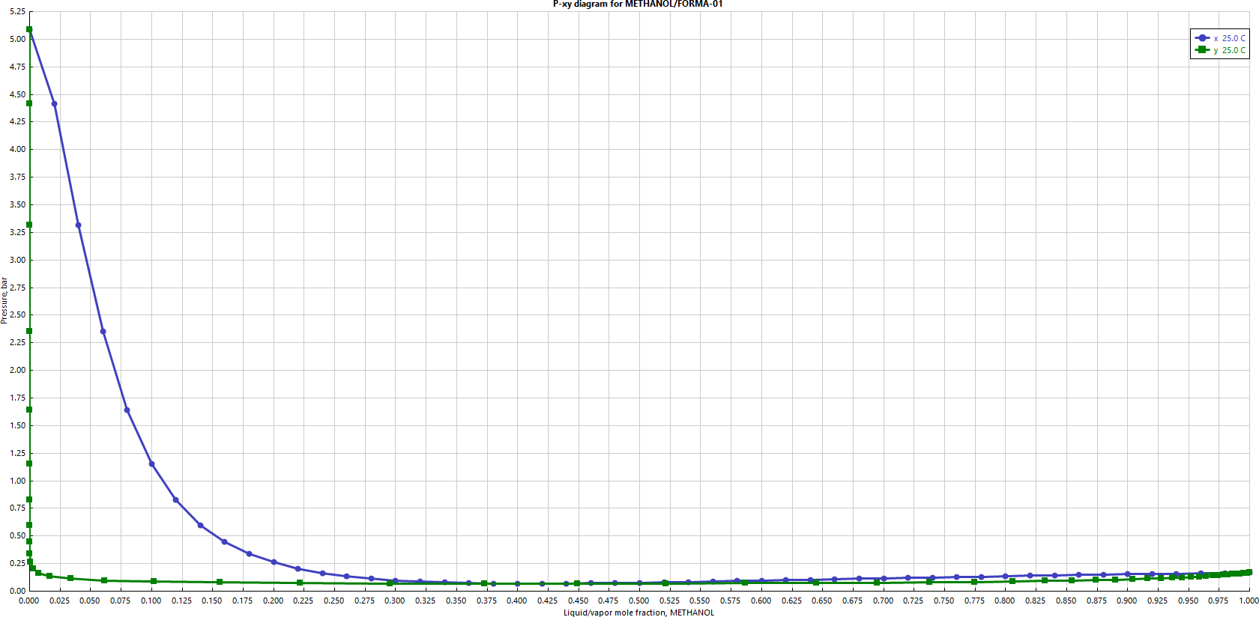

Pressure **vs** liquid/vapour mole fraction of METHANOL

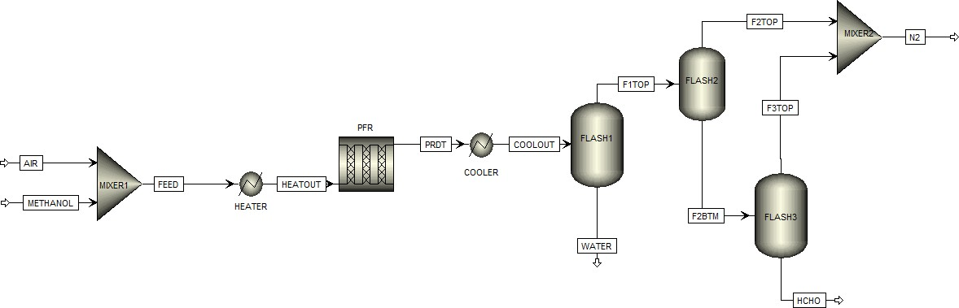

# Feed :-

* Air

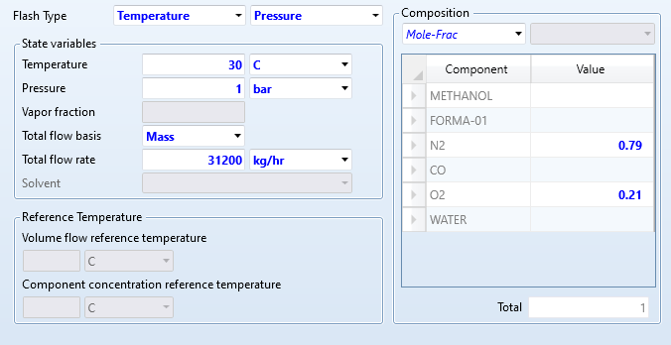

* Methanol

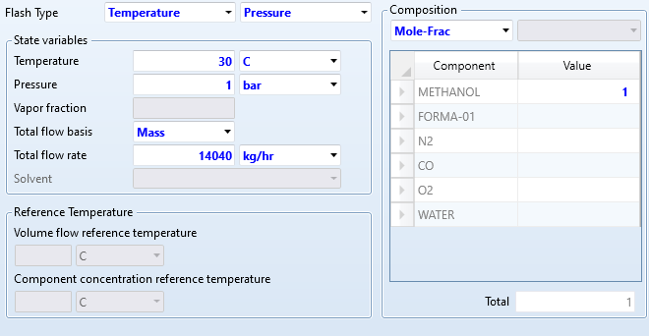

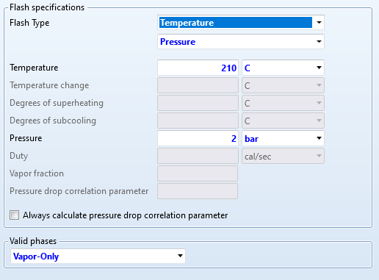

* Stream Results

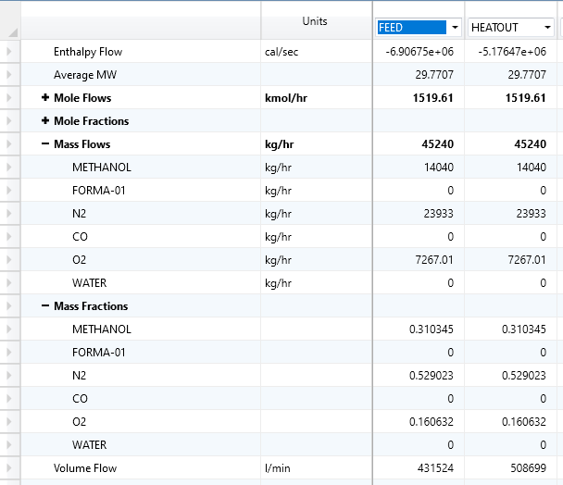



* Configuration

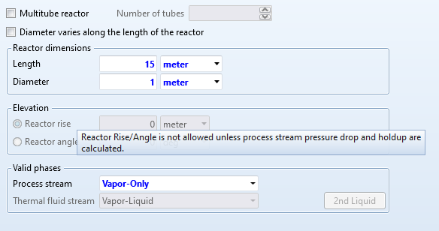

* Catalyst

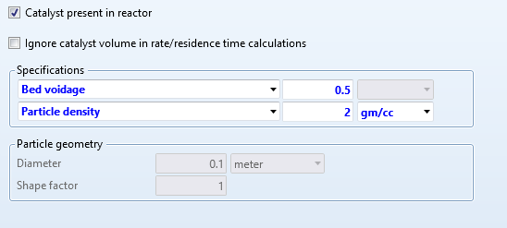

* Stream Results

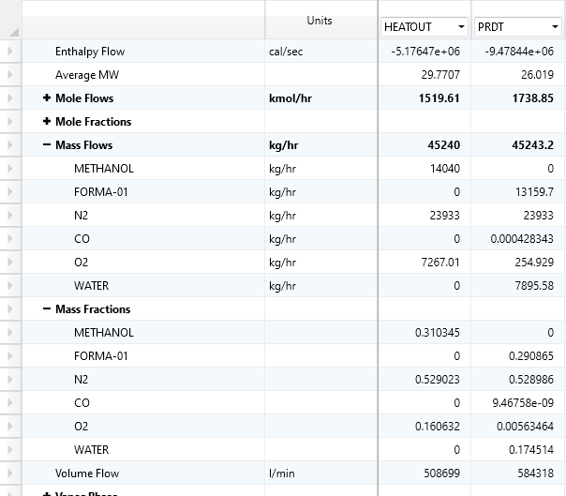

* Profiles

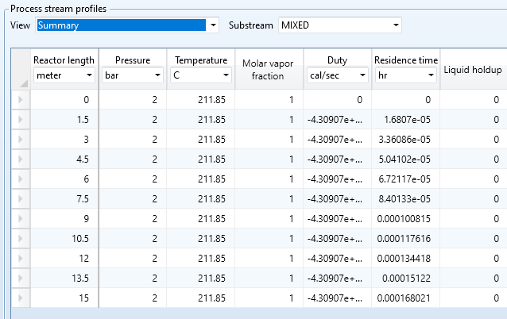

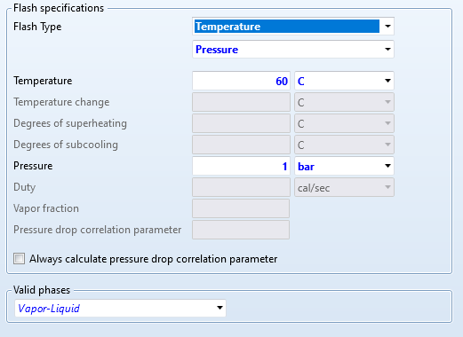

* Stream Results

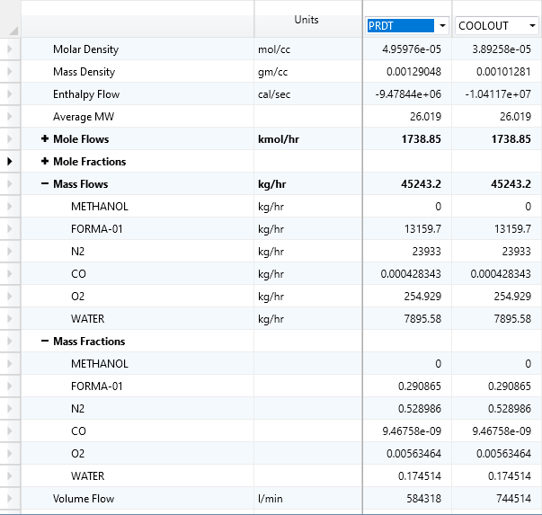

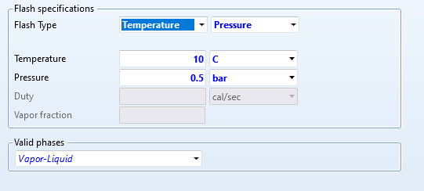

* Stream Results

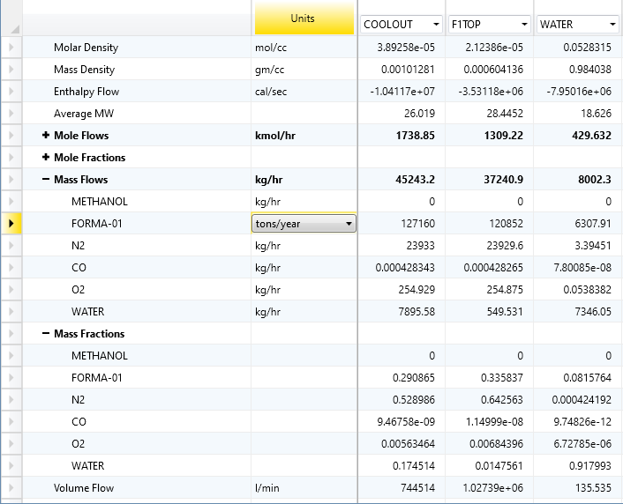

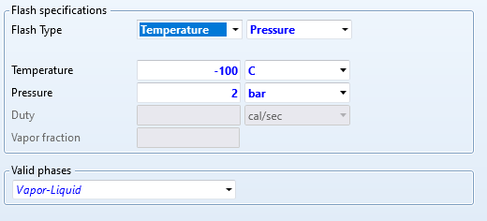

* Stream Result

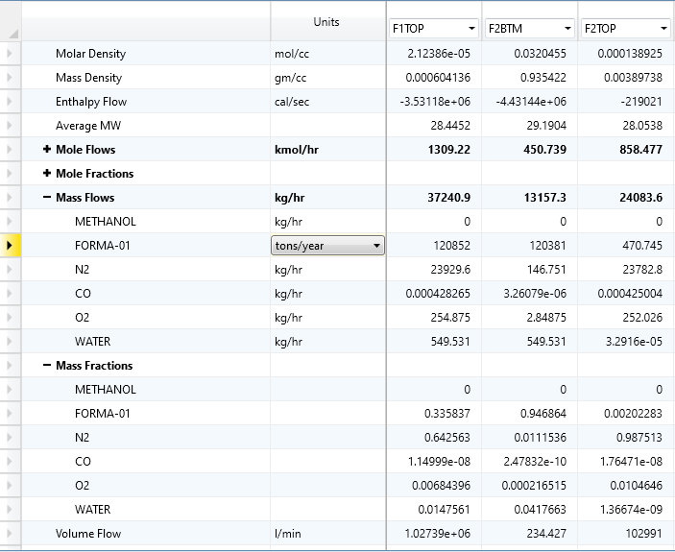

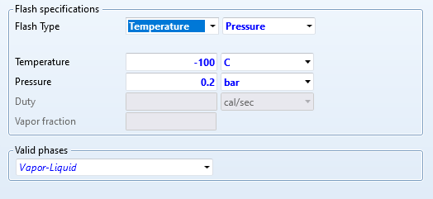

* Stream Result

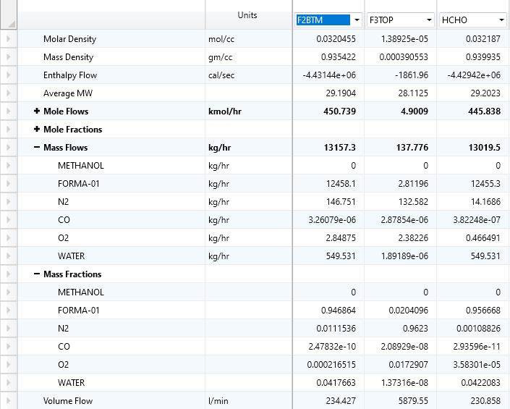

# Reactions :-



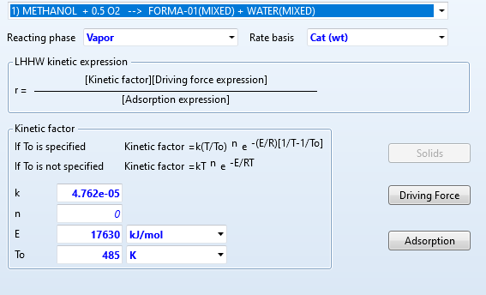

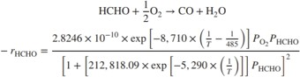

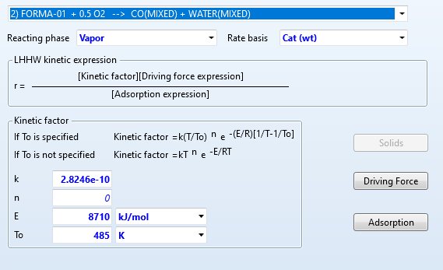

* Summary

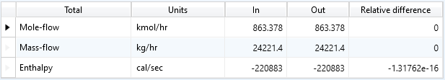

* Stream Result

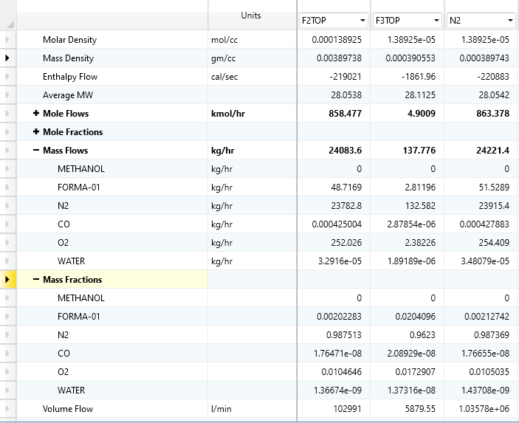

* F 1

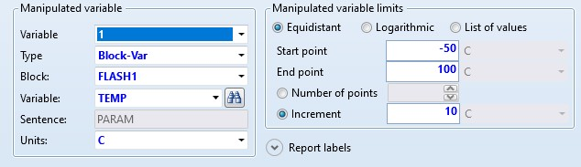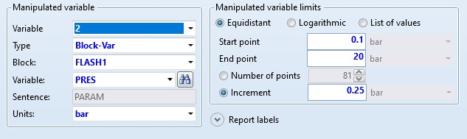

* F2

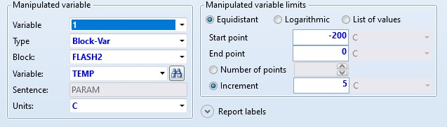

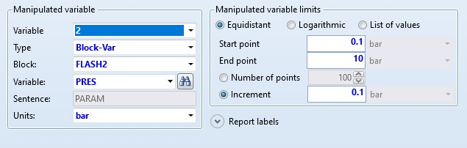

* F3

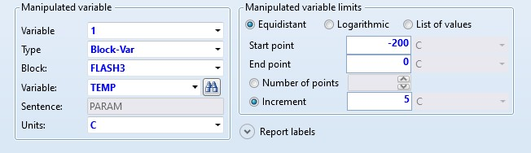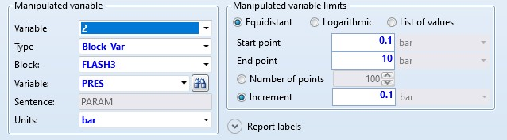

* PFRS

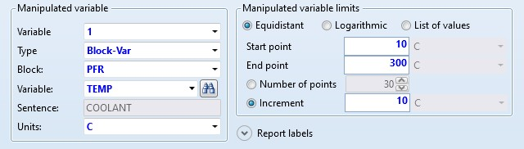

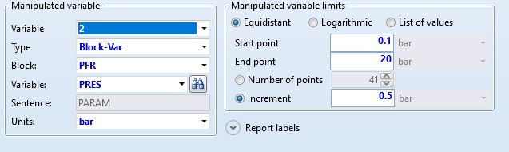

# Final Stream Result

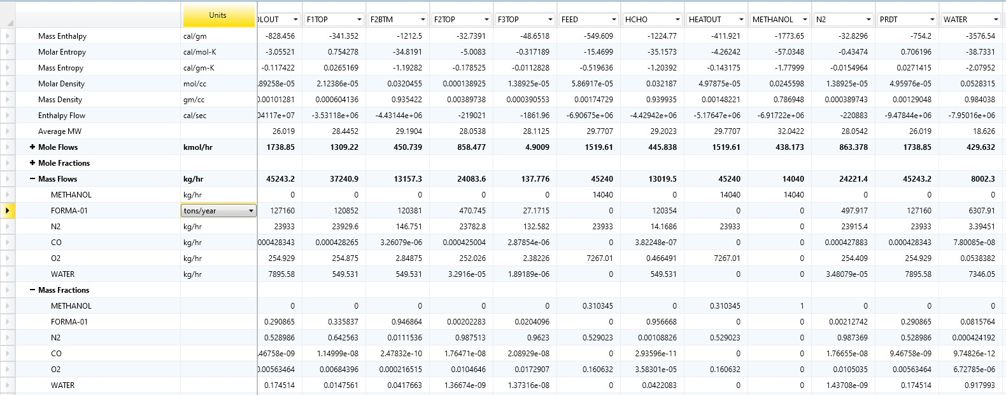

Conclusion :-

* The mass fraction of the final Formaldehyde is 0.95668 which is obtained from the bottom of flash drum 3
* The mass fraction of the final nitrogen content is 0.987369 which is obtained from the mixer 2
* The mass fraction of the final water content is 0.917339 which is remove from the bottom of flash 1
* For the given feed,the final mass flow rate of formaldehyde is 120354 tonns/hour